User case: View Store Information

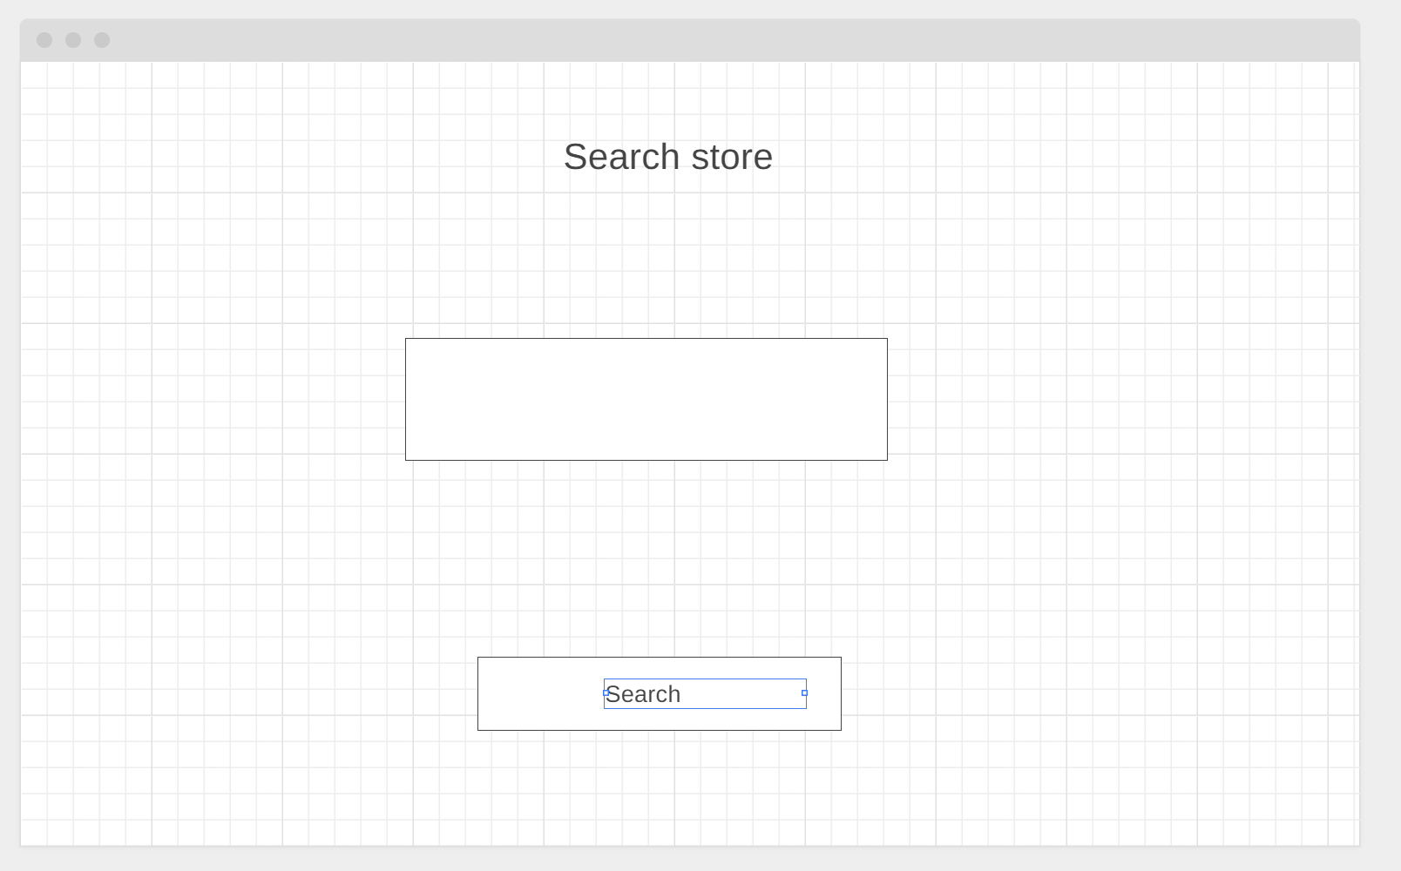

Frame 1: Search store

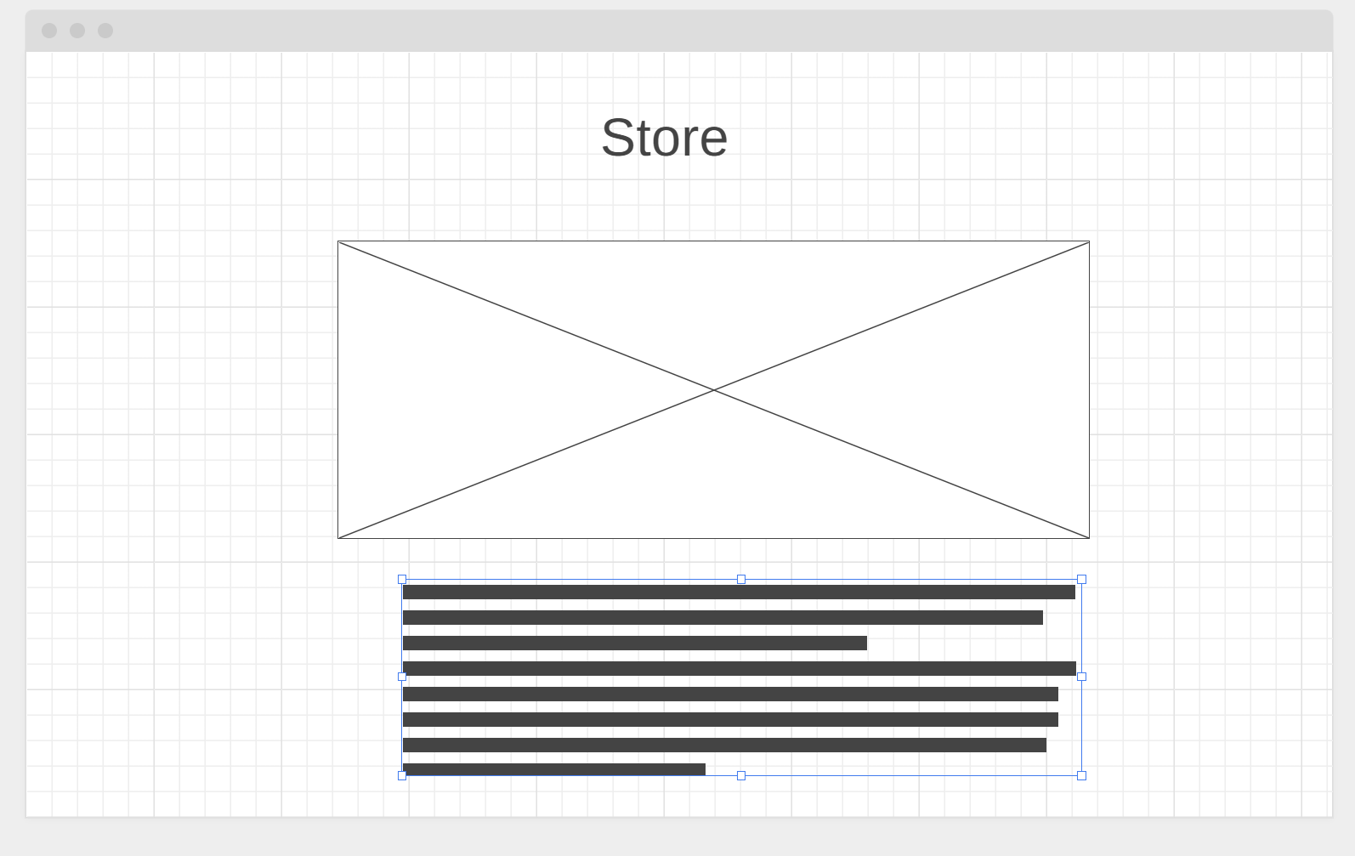

Frame 2: View store information

User case: Identify Top Selling Items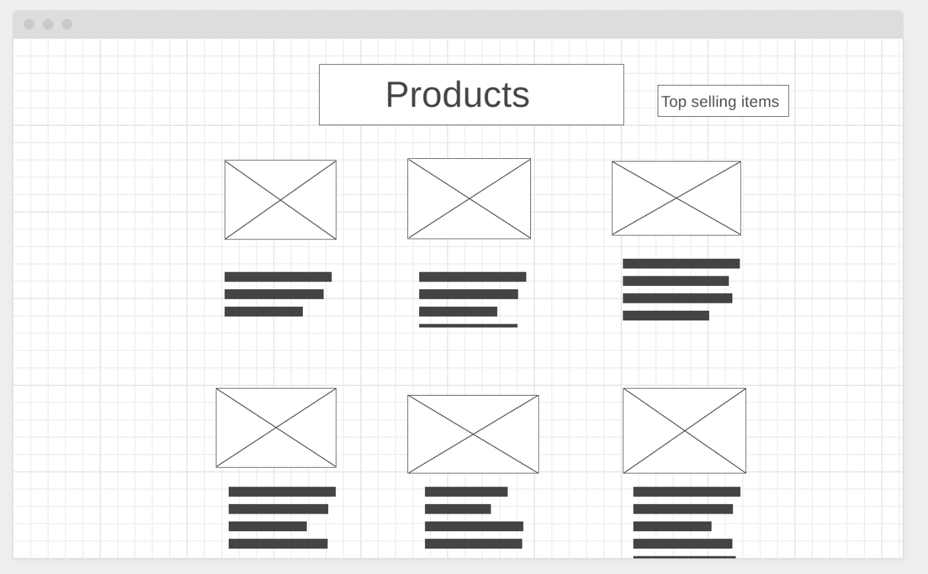

Frame 1: List of Top selling items

User case: Weekly Sales, Profit, Returns, Etc.

Frame 1: admin login page

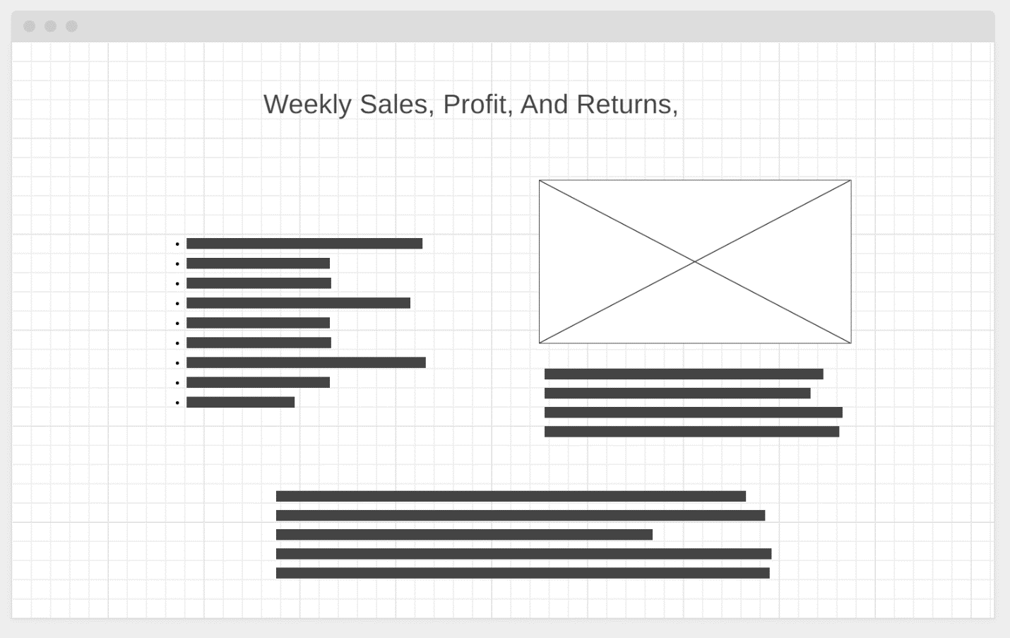

Frame 2: info and charts for weekly sales, profit, returns

User case: Add a new Customer

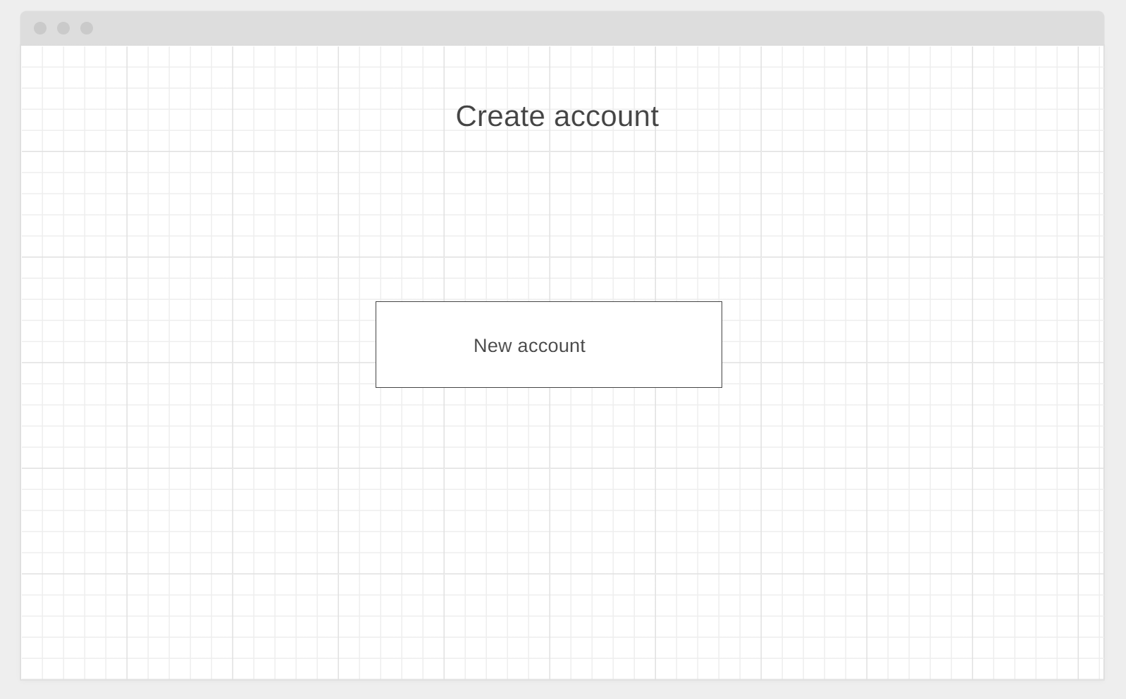

Frame 2: account info page

User case: Add a new Vendor

Frame 1: admin login page

Frame 2: vendor info page

User case: Add a new Store

Frame 1: admin login page

Frame 2: store info page